FTF FY 2023 Performance Scorecard USAID Zambia

This Feed the Future (FTF) Performance Scorecard assesses the USAID Zambia progress toward FY 2030 Performance Targets.

# Performance Overview



The FY 2023 **On track** value is determined by drawing a line from the baseline (FY 2022) to the FY 2030 Target. For FY 2023, Performance Targets are considered **On track** if they have reported at least 90% of that value.

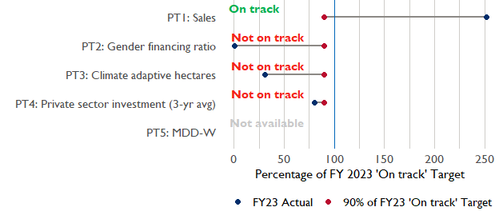

**Note:** *For Performance Target 2 (Gender financing ratio), the target is to increase financing to females for those OUs that are already achieving parity ($1).*

*For Performance Target 4 (PSI), all targets are relative to the last three years’ reporting. In future years, the interim targets may increase.*

*For Performance Target 5 (MDD-W), all FY23 actual values are also the baseline, and may have been collected in a prior year. See the detail page for more information.*

*See detailed* [*methodology document*](https://docs.google.com/document/d/13n-43ppFiGKauscQ7HaAiQDCM4DssGEgRdq2fMyTDn0/edit) *here. If you have questions, please email the FTF Data and Analytics team at* [refs.adl.da@usaid.gov](mailto:refs.adl.da@usaid.gov).

### Performance Target (PT) Details

This section shows PT scores for each applicable PT for USAID Zambia.

## Performance Target 1: Value of annual sales of producers and firms receiving USG assistance



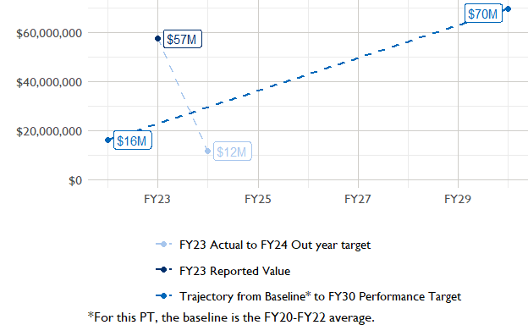

In FY 2023, USAID Zambia had 3 activities that aligned the ‘Value of annual sales from producers and firms receiving USG assistance’ (EG.3.2-26), and 2 contributed to the sales total of $57,460,000.  
Note that while USAID Zambia was ‘On track’ in FY23, it expects a substantial decrease in FY24. Such an increase would make it ‘Not on track’ for this performance indicator.

###### Performance Target 2: Value of financing accessed by female FTF participants per $1 of financing accessed by male FTF participants



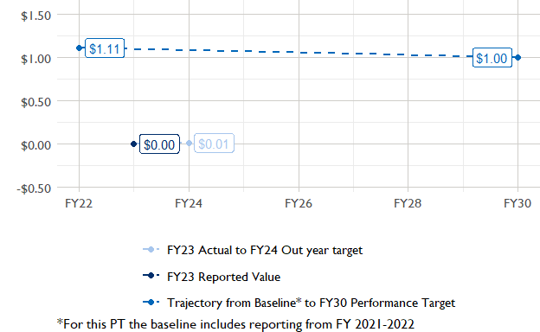

In FY 2023, USAID Zambia had 2 IMs/Activities that reported all four sex disaggregates needed to contribute to PT2. The total value of financing among all activities, regardless of disaggregates, was $5,780,000 (EG.3.2-27 total), with $5,780,000 that was disaggregated by females and males, and an additional $5,810,000 to ‘mixed’ firms that have both males and females, and NA that was not sex disaggregated.

###### Performance Target 3: Number of cultivated hectares under climate adaptation/climate risk management practices and technologies with USG assistance



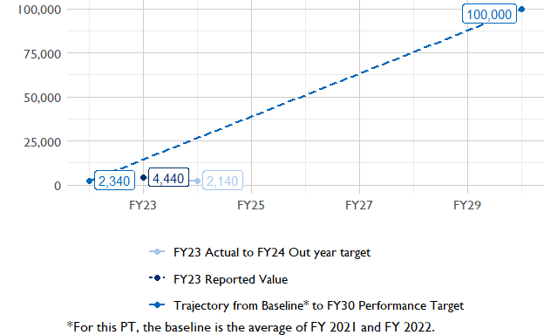

In FY 2023, USAID Zambia had 10 activities that aligned the indicator for hectares under improved management practices (EG.3.2-25). Of those activities, 2 reported on the ‘Climate adaptation/climate risk management’ disaggregate and contributed to the OU total for this PT.

###### Performance Target 4: Value of private sector investment leveraged by the USG to support food security and nutrition



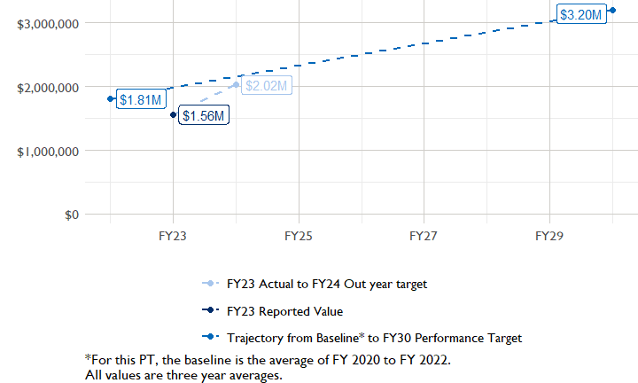

In FY 2023, USAID Zambia had 1 activity that aligned the private sector investment indicator (EG.3.1-15/-14), ‘Value of new private sector investment leveraged by the USG to support food security and nutrition [IM-level]’, and 1 contributed to the OU total in FY 2023.

###### Performance Target 5: Percent of women consuming a diet of minimum diversity (MDD-W)



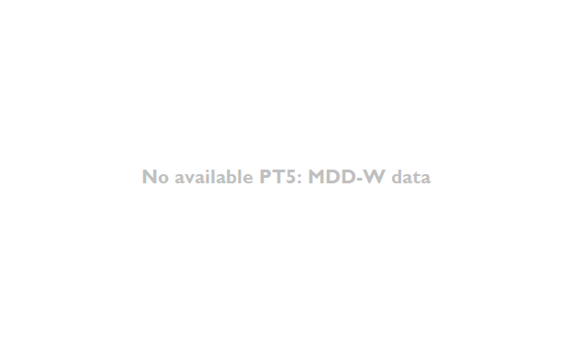

PT5 is not available for USAID Zambia.

### National Context

National level data was collected from the [World Bank’s Open Data portal](https://data.worldbank.org/) that measures key indicators at the national level.

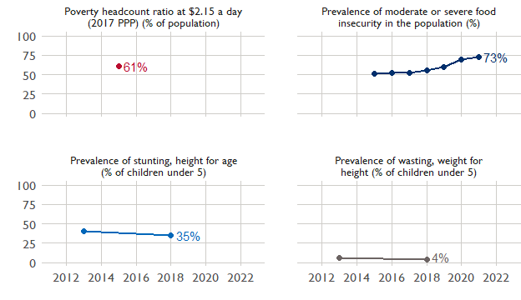

## Agricultural Transformation Index Score

The IFPRI Agricultural Transformation Index (ATI) Score is a high level indicator of the status of agricultural market systems in each country.

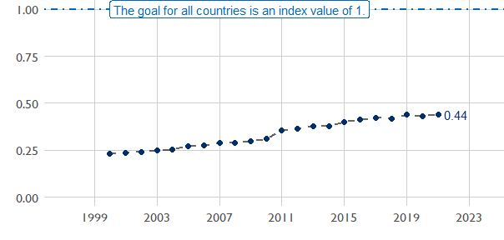

## Budget Trend

At the Operating Unit level, the Performance Targets are based in part on the FY 2024 budget request. The budget chart below includes EG.3 money only.

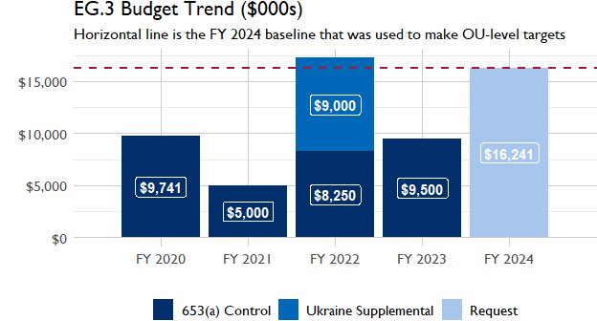

## Active Portfolio

The following activities are considered “active” based on their reporting in FY 2023 and expected FY 2024 reporting. The Analytics, Data and Learning Division defines an “active” activity as one that reported targets, actuals, or deviation narratives for the current year (FY 2023), or the next out year targets (i.e. FY 2024).

## Top Activities (Award Disbursements and Results)

This section highlights the 5 activities (out of the total 10 in the USAID Zambia (ZAMBIA) portfolio) that have the highest level of FY 2023 annual disbursements and highest reported values for the relevant indicators. The first table below shows activities with the highest total transaction amounts. The columns to the right indicate if these activities are reporting on relevant PT indicators.

| Award Number | Activity Code | Activity Name | FY23 Disbursements | PT1 | PT2 | PT3 | PT4 |
| --- | --- | --- | --- | --- | --- | --- | --- |
| 72061120C00006 | 1713 | USAID Enterprise Development Growth Enhanced (EDGE) | $3,145,251 | X | X | - | - |
| 72061121CA00003 | 1710 | 106661: Eastern Kafue Nature Alliance - Health, Ecosystems, and Agriculture for Resilient, Thriving Societies (HEARTH) | $550,973 | - | - | - | - |

The next table (below) shows the activities that reported the highest values for the relevant PT indicators. The total disbursements are included, if available.

| Award Number | Activity Code | Activity Name | Total Disbursements | PT1: Sales | PT3: Climate adaptive hectares | PT4: PSI |
| --- | --- | --- | --- | --- | --- | --- |
| 72061120C00006 | 1713 | USAID Enterprise Development Growth Enhanced (EDGE) | $3,145,251 | $45,140,447 | NA | NA |
| 7200AA18CA00008 | 2425 | Alliance for Inclusive and Nutritious Food Processing (AINFP) -Zambia Buy in | $161,431 | $12,317,709 | NA | $1,380,865 |
| !! Not reported !! | 5560 | Luangwa Livelihood and Conservation Activity | NA | NA | 2 480 | NA |
| 72061119C00002 | 2400 | Scaling Up Nutrition Technical Assistance | $353,780 | NA | 1 964 | NA |
| 72061120CA00004 | 1707 | Emerging Farmers Partnership (EFP) | NA | NA | NA | NA |
| 72061121CA00003 | 1710 | 106661: Eastern Kafue Nature Alliance - Health, Ecosystems, and Agriculture for Resilient, Thriving Societies (HEARTH) | $550,973 | NA | NA | NA |

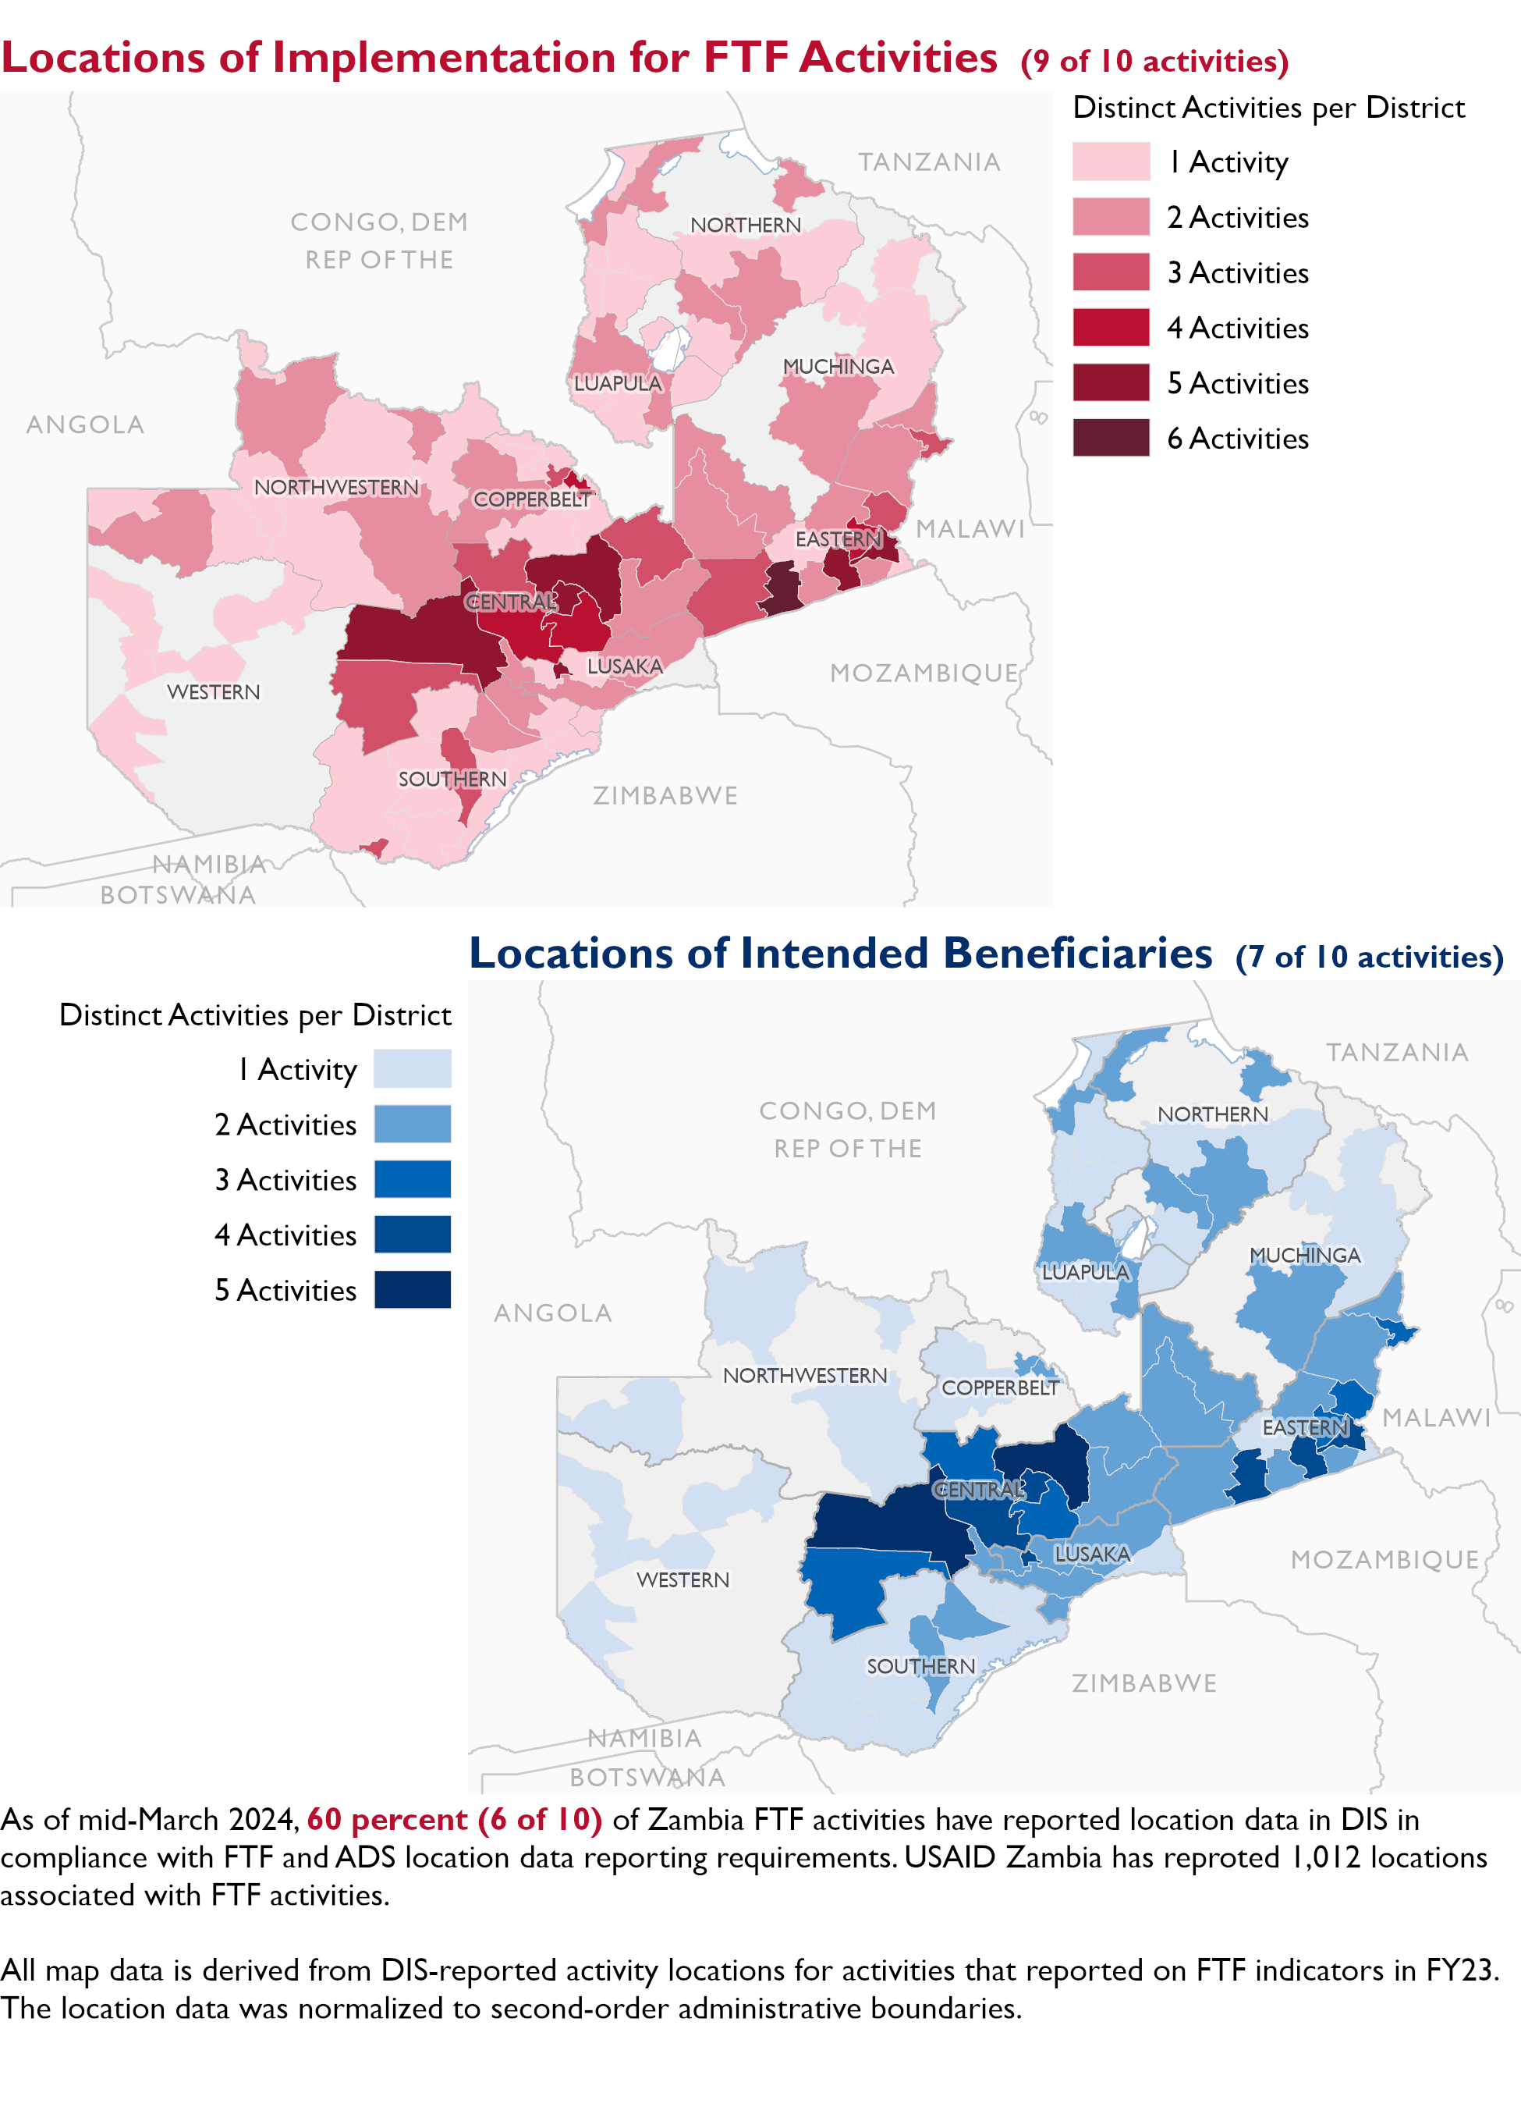

### Appendix 1: Response to “Not on track” Performance Targets

This section provides space for USAID Zambia to provide an explanation of why the following PTs are not on track and how you could adjust to be on track in the coming year(s). To help in your response(s), the relevant section of the FTF/GFS Key Issue Narrative (KIN) is provided, as it *may be* useful in drafting a responses. Note that the KIN is addressing the sum of the out year targets (FY 2023) set by the USAID Zambia activities that are reporting on each PT. The FY 2023 out year targets were set prior to the establishment of the FY 2030 Performance Targets, so the below explanations from the KIN may not apply to the Performance Target deviation.

* In Section 4 of the FTF KIN, your OU discusses FY24 and FY25 targets, while these Scorecards are addressing progress against a trajectory from historical reporting to your OU’s FY30 target. Also, the FY 2023 out year targets were set prior to the establishment of the FY 2030 Performance Targets. Therefore, the below explanations from the KIN may not apply to these FY30 Performance Target deviations.
* These responses will be used to compile a Congressional report, the GFSS Implementation Report, to discuss progress against the FTF FY 2030 Performance Targets, as mandated by the GAO.
* Only PTs that are ‘Not on Track’ require review and explanation from the OU.

Include the following two components in each response:

1. An explanation of why this target is not on track. Explanations may include that the OU/Mission was not aware of the target prior to planning activities. (Limit 100 words)
2. Planned actions for ‘not on track’ targets. Planned actions may include the launch of new activities, building awareness, holding portfolio reviews, or other suggestions. (Limit 100 words)

## Performance Target 2: Gender financing ratio [Not on Track]

*Excerpt from FY23 KIN Section 4 to consider:* target was unmet in Fiscal Year 2023. Despite many successes in increasing access to finance through support to Community Savings and Loans Groups (CSLGs) and SMEs, women still lag behind men in access to finance as larger loans to men-owned businesses overtook many of the small loans that women received through CSLGs. Women still face many difficulties in accessing loans from larger financial institutions, including lack the skills to financially manage businesses and low access to productive assets that can be used for loan collateral. This year, women slightly underperformed men ($0.98 per $1.00 loaned, compared to $) despite the met goal of almost 25% more loans to women, as compared to men this year. Through USAID-supported CSLGs, more than 80% of the over 86 thousand participants are women, but loan amounts were small, negatively affecting this indicator. USAID-supported women’s savings groups in Eastern Province were linked to the Farmers Out-grower Foundation, helping to expand the reach and formalization of investments by CSLGs. Through this partnership, women’s savings groups are assured of ready supply of inputs for production as well as markets for the final product, which has been one of the biggest challenges that SMEs face (especially women from rural areas). USAID also supported more formal out-grower schemes this year by connecting CLGSs with a private sector partner that supplied training, fertilizer, and seeds, and a guaranteed market for their produce. Even with these efforts and successes, challenges remain in providing more loans to women, and USAID/Zambia’s loan support programming must adapt to address this challenge. Over the next two Fiscal Years, USAID Zambia expects a reduction in the loan partly due to the closure of two programs that support finance. Successful loans under the CSLGs (which strongly favors female borrowers) will be reduced as FtF Zambia closes the program that supported this effort. A new bilateral program will provide support to CSLGs in the new FtF ZOI, but the award will not start until August 2024. As such, success on this target for the next two fiscal years will be reduced in gender parity to closer to 1:1.

#### Enter USAID Zambia’s explanation of why this target is ‘Not on track’ below (Limit 100 words):

#### Enter USAID Zambia’s planned actions for ‘Not on track’ targets below (Limit 100 words):

## Performance Target 3: Hectares under climate adaptive and risk management practices [Not on Track]

*Excerpt from FY23 KIN Section 4 to consider:* Zambia’s FtF program exceeded the target for land under improved climate adaptation and risk management practices, through growth of programming with private companies, including support to increase the number of smallholder farmers, and expansion of climate smart agricultural practices and value chains. Two USAID conservation-oriented activities contributed to achieving success this year. Increased investment in climate-friendly honey, cowpea, groundnuts, soybeans value chains (among others) helped to increase soil fertility and increase production. Support for agroforestry production systems helped to create a sustainable, productive landscape that met several conservation and livelihood goals by connecting fragmented forests and creating corridors for wildlife movement. Support to lead and follower farmers programs also led to increased production of nutritious food in vulnerable communities this year. An increased area under improved management fulfills multiple productive goals, improves livelihoods and helps to maintain the integrity of iconic Zambian landscapes. Growing partnerships with the private sector was key this year to this success. The development of new partnerships with private sector-run outgrower schemes helped contribute to higher areas of land under conservation agriculture than anticipated as new projects hit a two year milestone. As new work continues under these programs and new ones come online in Fiscal Year 2024, we expect a moderate level of performance on this indicator, roughly in line with the 2023 FY target. New partnerships were very successful in achieving this target this year, but we do not expect similar results over the next two years.

#### Enter USAID Zambia’s explanation of why this target is ‘Not on track’ below (Limit 100 words):

#### Enter USAID Zambia’s planned actions for ‘Not on track’ targets below (Limit 100 words):

## Performance Target 4: Private sector investment [Not on Track]

*Excerpt from FY23 KIN Section 4 to consider:* Zambia’s FtF program exceeded the target for land under improved climate adaptation and risk management practices, through growth of programming with private companies, including support to increase the number of smallholder farmers, and expansion of climate smart agricultural practices and value chains. Two USAID conservation-oriented activities contributed to achieving success this year. Increased investment in climate-friendly honey, cowpea, groundnuts, soybeans value chains (among others) helped to increase soil fertility and increase production. Support for agroforestry production systems helped to create a sustainable, productive landscape that met several conservation and livelihood goals by connecting fragmented forests and creating corridors for wildlife movement. Support to lead and follower farmers programs also led to increased production of nutritious food in vulnerable communities this year. An increased area under improved management fulfills multiple productive goals, improves livelihoods and helps to maintain the integrity of iconic Zambian landscapes. Growing partnerships with the private sector was key this year to this success. The development of new partnerships with private sector-run outgrower schemes helped contribute to higher areas of land under conservation agriculture than anticipated as new projects hit a two year milestone. As new work continues under these programs and new ones come online in Fiscal Year 2024, we expect a moderate level of performance on this indicator, roughly in line with the 2023 FY target. New partnerships were very successful in achieving this target this year, but we do not expect similar results over the next two years.

#### Enter USAID Zambia’s explanation of why this target is ‘Not on track’ below (Limit 100 words):

#### Enter USAID Zambia’s planned actions for ‘Not on track’ targets below (Limit 100 words):